ZANESVILLE P.A.L. BOXING GYM, RAFFLE PURCHASE INFORMATION
KEEPING OUR DOORS OPEN FOR OUR KIDS THIS WINTER
OPTION 1 — PURCHASE THROUGH VENMO
Scan the QR code below or search for our Venmo: zanesvillepal
(Look for the gym logo)
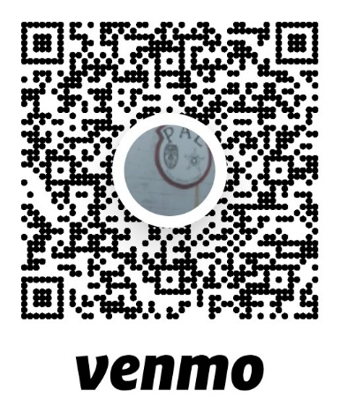
IMPORTANT:
When sending payment, include your full name, phone number, and which raffle(s) your tickets should go toward (Shotgun, 350 Legend).
Your digital ticket numbers will be logged and confirmed by message after purchase.
Please include your full name in Venmo notes.
OPTION 2 — BUY TICKETS IN PERSON
You can stop at the gym during training hours:
804 Pine Street, Zanesville, Ohio
Tuesday–Thursday, 5–7 PM
Cash purchases welcome.
We will record your ticket entries on-site and provide confirmation immediately.

OPTION 3 — CONTACT A P.A.L. VOLUNTEER DIRECTLY
If you need help purchasing, have questions, or prefer to buy over the phone, you may contact:
Matthew Lincicome
Organizer, Volunteer
📞 614-420-0888
Josh Ward
Coach & Vice President
📞 740-319-9794
Email: zanesvillepal@outlook.com
Any of us can assist with raffle purchases, verification, or general information.

