ZANESVILLE P.A.L. BOXING GYM FUNDRAISER
KEEPING OUR YOUTH STRONG THIS WINTER
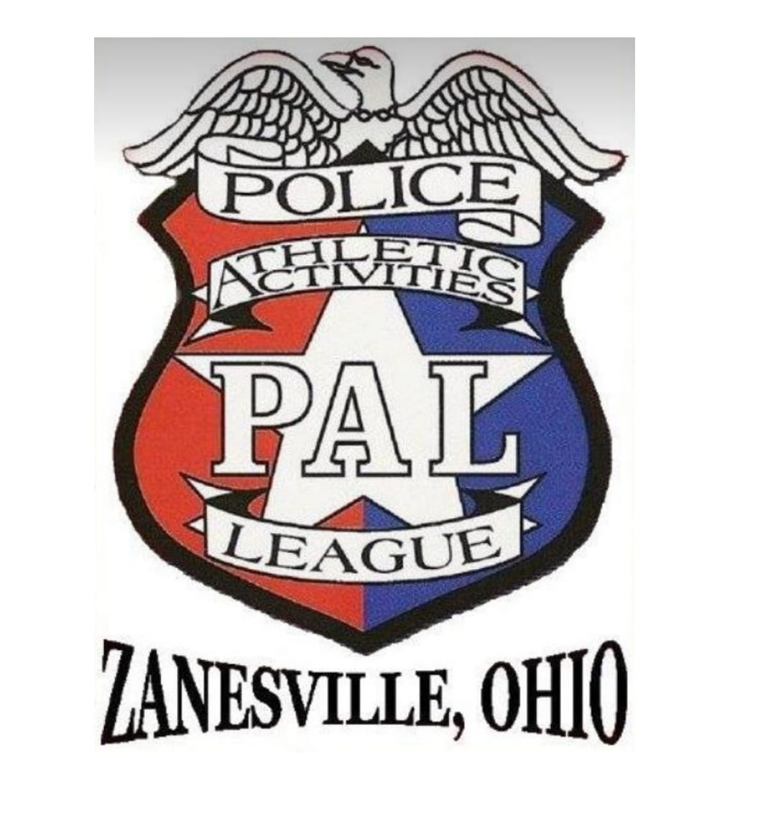
804 Pine Street
Zanesville, Ohio - Training Hours: Tuesday–Thursday, 5–7 PM
Come visit and see who we are, FREE training, real boxing experience, real community impact.
ABOUT THE GYM: Zanesville P.A.L. Boxing Gym provides a safe, structured, and completely FREE space for kids, teens, and adults. Volunteer coaches dedicate their time to teaching discipline, confidence, physical fitness, and positive life habits.
WHY WE NEED HELP: Our gym operates in a historic brick warehouse with almost no insulation. Winter utility costs rise to nearly $2,000 per month just to keep the gym warm enough for safe training. Without community support, we risk being forced to close for the winter, leaving dozens of youth without a safe outlet, routine, and guidance.
OUR WINTER FUNDRAISER:
First wave of firearm and baskets raffle begins December 1st.
• Raffle baskets filled with donated items
• Multiple firearm raffles throughout December
• All proceeds directly support heating and utilities
HOW YOU CAN HELP:
• Participate in our raffles
• Donate items or gift cards
• Share our fundraiser and spread the word
• Support the gym by encouraging community involvement
GoFundMe: https://gofund.me/b57caba0f
A STRONGER COMMUNITY STARTS HERE: Your support keeps our doors open, our kids safe, and our community strong. Thank you for standing with us.
SEE BACK SIDE
Follow us on Facebook @ Zanesville P.A.L. (Police Athletic League) & Zanesville PAL boxing
If you need help purchasing, have questions, or prefer to buy over the phone, you may contact:
Matthew Lincicome
Organizer, Volunteer
📞 614-420-0888
Josh Ward
Coach & Vice President
📞 740-319-9794
Email: zanesvillepal@outlook.com
Any of us can assist with raffle purchases, verification, or general information.

