FIREARM RAFFLE PRICING (FINAL)

RAFFLE #1 – MERIVA 12GA PUMP SHOTGUN (18.5" BARREL, 5-ROUND)
This is a rugged, no-nonsense 12-gauge pump shotgun that everyone can use. It’s perfect as a home-defense shotgun, a truck gun, or a barn and farm workhorse. Simple, tough, easy to run, and built to be used without worrying about babying it.

Ticket pricing (4 tiers):
• 1 ticket – $5
• 5 tickets – $20
• 10 tickets – $35
• 15 tickets – $50
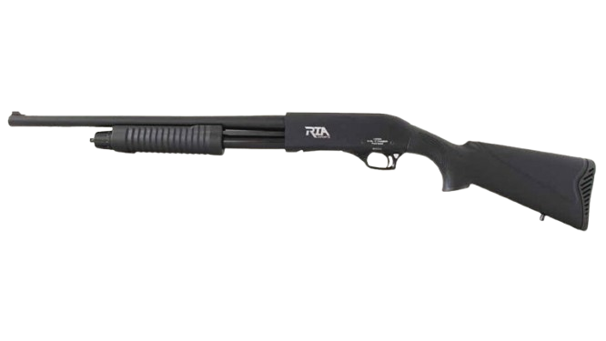
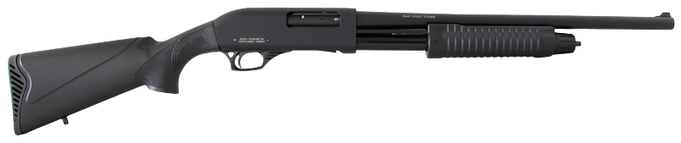

SEE BACK SIDE

RAFFLE #2 – CHIAPPA BIG BADGER 350 LEGEND SINGLE-SHOT FOLDING RIFLE
This is a lightweight, compact rifle chambered in 350 Legend, one of Ohio’s most popular straight-wall deer calibers. It folds for easy storage and carry, making it perfect for the truck, the cabin, the blind, or the backpack. It’s simple, safe, and practical, a great tool for hunters or anyone who wants a compact, hard-hitting rifle in a legal Ohio deer round.

Ticket pricing (4 tiers):
• 1 ticket – $10
• 5 tickets – $40
• 10 tickets – $75
• 15 tickets – $100
